Clinical and Medical Education & Training
Funding Application Form

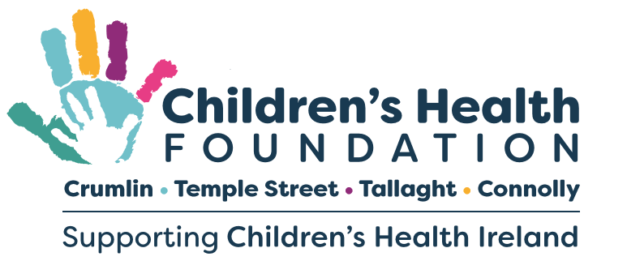

Children’s Health Foundation Key Funding Pillars

*Please tick the most appropriate funding pillar
New & Emerging Services | Impact Initiatives for Patients, Parents & Staff

Applicant Details

Prepared By:
Email Address:
Phone Number:
Department/Ward/Office
CHI Site:
Date Submitted:
Amount Requested: | *Please state full course fees
Are you a permanent CHI staff member?

SUBMISSION GUIDELINES

Children’s Health Foundation considers clinical and medical education and training funding applications from staff in Children’s Health Ireland (CHI) hospitals and urgent care centres.
This funding call aims to support individuals who wish to continue their medical education, therefore improving health services and providing patients and families with the best care possible.

This process is open to staff who wish to pursue Academic Study and Professional Training that will bring a benefit and impact within one of the above Children’s Health Foundation key funding pillars.

All sections of this application form must be completed and signed with all supporting documentation e.g., Course guidelines, fees, schedule, Accreditation etc. attached to clearly articulate the need and benefits of the training. Each section must be filled out in a clear and concise manner, with consideration given to the panel members, who are of a non-medical background.

Applications will only be accepted as a single PDF document. Applications submitted in any other form, incomplete or multiple documents will be automatically excluded from the process. The application form should be scanned and emailed in PDF format only to grants@childrenshealth.ie applications will only be accepted for consideration from this email account.

CHF Education and Training Funding Priorities and Parameters

Priority will be given to training that has a direct impact on the services and care provided to patients and their families. Following a review of the applications received at our last Education and Training Funding Call the following priorities and parameters will apply for 2023

Priority will be given to:
Patient-focused team members – CHI staff members who have direct regular contact with patients as part of their role.
Training that will have a direct impact on child and patient health.
Applicants that are not in receipt of additional Education / Training funding.
Applicants who are not currently enrolled on an Education or Training course.
Permanent Staff members with a minimum of 1 years’ service

Factors to be taken into consideration when applying for funding:
One application for training per person, we do not accept group applications.
Training must be beneficial to the applicant's work and departmental needs.
CHF will fund 50% of the total course fee of successful applicants up to a maximum of €5,000. Successful applications with requests of €1,000 or less will be fully funded.
Documentation for all costs must be submitted with the application form.
Travel expenses must be in line with the CHI Travel & Expense Policy, and per the CHI Education & Study Support Policy.

Please Note: By submitting this proposal you confirm that all information included in this application is correct and can be used by the Foundation for information purposes. Awarded funding is for the 2023/2024 academic year and must be utilized within 6 months. If the drawdown of funds is not completed for the 2023/2024 academic year, they will be released back to CHF to be used for other worthy causes.

Clinical and Medical Education and Training Application Form

Programme Title

Programme Accreditation

Programme Type
Academic Study | Professional Training

Programme Schedule
Start Date |  | End Date

Programme Duration – tick appropriately where programme duration is 1 or more Years.
1 Year | 2 Years | 3 Years | 4 Years

Has the course/programme already commenced: Yes No

Priority will be given to Applicants who are not currently enrolled on an Education or Training course

Please describe the education/training programme for which you are seeking funding.

Background and Context: Rationale for Support
Please provide a brief outline of the reason behind this funding request.

Outcomes: Please tell us what outcomes you are aiming to achieve to support your department.

Please detail how many beneficiaries will be impacted on an annual basis and the types of beneficiaries eg. patients, parental support.

Why would a donor want to fund and support this activity?
Please refer to CHF’s funding priorities in your answer
*Please explain why a donor would be compelled to fund this activity. This question is mandatory in order to provide key information to donors on our goals and impact.

Budget

Budget Categories | Year 1 | Year 2 | Year 3 | Year 4 | Total
Education/Course Costs
Other Costs
Eg. Consumables
Total

CHI Authorisation

Proposer
Name
Signature
Date
Department Head
Name
Signature
Date

Please list additional documentation in support of this application:

APPENDICES
Please check you have included the essential documentation required in support of this application
Appendix | Document Type | Received by CHF
Appendix 1 | E.g. Course Outline & Fees
Appendix 2 | E.g. Supporting Project Proposal
Appendix 3

CHF Education and Training Funding Priorities and Parameters

Priority will be given to training that has a direct impact on the services and care provided to patients and their families. Following a review of the applications received at our last Education and Training Funding Call the following priorities and parameters will apply for 2023

Priority will be given to:
Patient-focused team members – CHI staff members who have direct regular contact with patients as part of their role
Training that will have a direct impact on child and patient health
Applicants not in receipt of additional Education / Training funding
Applicants who are not currently enrolled on an Education or Training course
Permanent Staff members with a minimum of 1 years’ service

Factors to be taken into consideration when applying for funding:
One application for training per person, we do not accept group applications.
Training must be beneficial to the applicant's work and departmental needs

CHF will fund 50% of the total course fee of successful applicants up to a maximum of €5,000.
Successful applications with requests of €1,000 or less will be fully funded.
Documentation for all costs must be submitted with the application form.

Terms & Conditions

- Course details and Accreditation are subject to review by Children’s Health Foundation and HR at CHI.
- A Grant Reference will be issued where funding has been awarded and must be used on all correspondence relating to funding.
- Grant disbursement is coordinated by HR at CHI and the department will be supplied with confirmation of grant awarded by Children’s Health Foundation
- Grants disbursed are subject to HR at CHI policy in the case of an employee leaving or where an employee is unable to complete a course for which funding support has been provided.
- Travel expenses must be in line with the CHI Travel & Expense Policy, and per the CHI Education & Study Support Policy.

CHF Use Only – Children’s Health Foundation
CHF Decision:
Conditions Applied:
Signature:
Date Approved:

